**Assignment 1**

**File System Management**

1. List out 5 files in your system which consuming most of the disk space

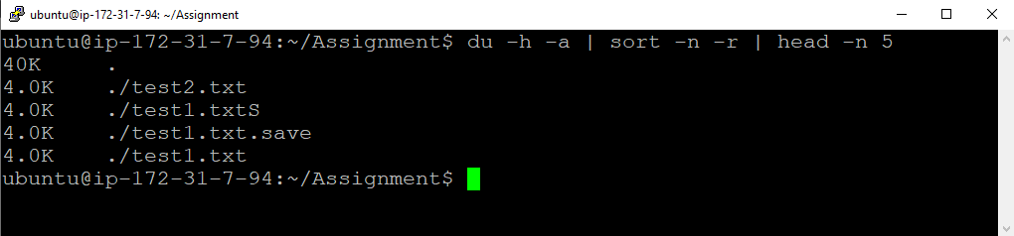

Commands :

du –a :- disk usage for all files

sort –r :- sorting reverse

head –n 5 :- show first 5 results only

2) Create one common folder in such way that anyone can create files inside that independently and should not be able to delete other users files from that common folder.

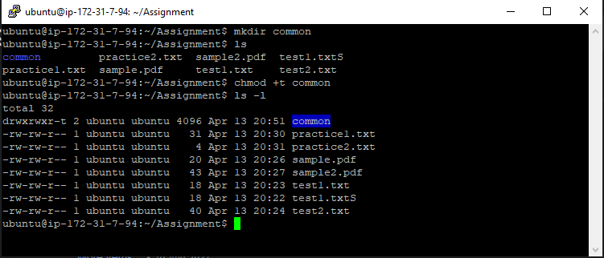

Commands :

mkdir : Making Directory

chmod +t :- give sticky bit permission

ls -l :- checking permission of all files

3) Create user name "Shubham" and add that user in the group "adm"

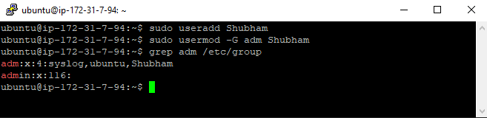

Commands :

sudo useradd :- Adding the new user

sudo usermod -G adm Shubham:- Adding the user into Group

grep adm /etc/group :- Checking Group and their Users

a) Create folder /data , change owner and group as  "root:adm”

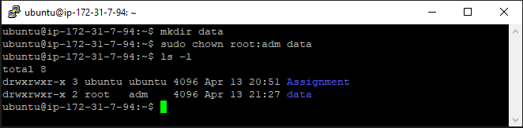

Commands :

mkdir data:- Making Directrory data

sudo chown root:adm data :- Changing Owner and Group

ls -l :- checking details of owner and group of all files

 b) Change /data permission such a way that user can able to write data in this folder and ownership of files or folder which you creates in this folder should be same as parent folder i.e /data folder permission (root:adm) .

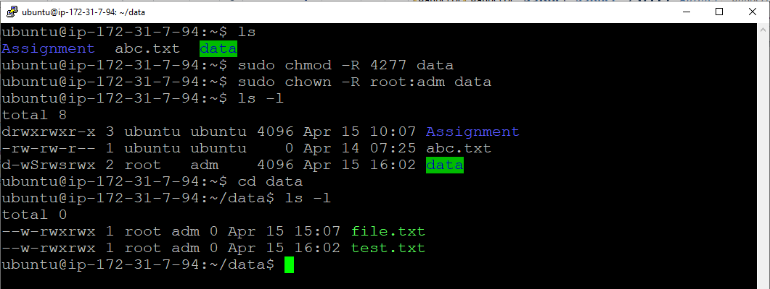

Commands :

sudo chmod –R 4277 data :- set only write permission for user to folder and subfolders using –R.

sudo chown –R root:adm data :- change/set user and group to folder and subfolders using –R.